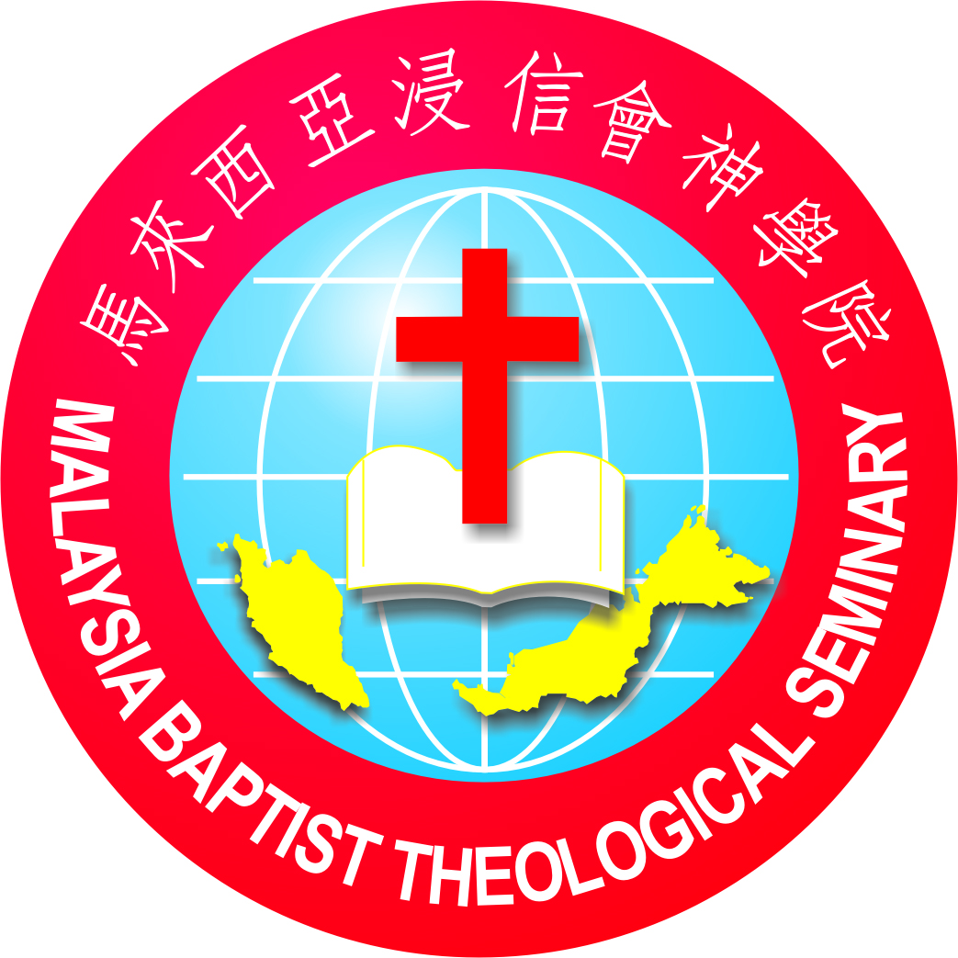
Malaysia Baptist Theological Seminary (Main Campus)
20241st Term Schedule
For course registration, please visithttps://forms.gle/R85U48M7AE8EyWNX6
*Course Registration Closing Date: 22ndDecember 2023
*Course Registration Fee RM20 will be waived if the registration is submitted on or before the closing date.

Code | Course | Credit | Lecturer | Target Group Student
BS1118 | Introduction to Biblical Interpretation | 3 | Chia Wei Wenn | 1st year
GS101/GS1101 | Form & Style  (Online Asynchronous + Onsite tutoring)  8 January – 21 April  (15 weeks duration) | 2/ 1 | Mok Kok Hoong | 1st year
BS120 | Introduction to the New Testament | 3 | Stella Lau &Eric Pua | 1st& 2nd year
TH102 | Christian Theology II | 2 | Dr. Matthew Deaver | 1st& 2nd year
TH109 | Church History II | 3 | Chia Wei Wenn | 1st& 2nd year
TH1237 | Denominational Studies: Baptist | 3 | Dr. Thomas Chin | 1st, 2nd& 3rd year
TH330 | Acts, the Church and Culture | 2 | Dr. Ken Morrow | 1st, 2nd& 3rd year
OT1101 | Genesis  (Online Synchronous)  5, 12, 19 March; 2, 9, 16, 23, 30 April  8 – 10 p.m. (8 Tuesdays) | 3 | Dr. Kyle Essary | 2nd& 3rd year
GS111/211/311 | Spiritual Formation | 1 | Faculty | 1st, 2nd& 3rd year
GS511/512/513 | Practicum (Mentoring) | 1 | Faculty | 1st, 2nd& 3rd year
GS1514/GS516 | Internship (BTH / MDIV) | 3 / 2 | Practicum Director | 1st, 2nd& 3rd year
GS1508 | Ministry Practicum | 3 | Practicum Director | CTE
GS1506 | Preaching Practicum | 3 | Practicum Director | CTE
** 8Jan2024 Monday 10am Orientation Day

Week 1 – 4(8 Jan – 2Feb)
 | Tue | Wed | Thu | Fri
8:00 – 9:45am | Christian Theology II |  | Christian Theology II
10:00 –11:00am | Chapel | Chapel | Spiritual Formation | Mentoring
11:15am–1:00pm | Church History II | Church History II | Intro to NT | Intro to NT

Week 5(5 – 9Feb)
 | Tue | Wed | Thu | Fri
8:00 – 9:45am | Christian Theology II | Intro to NT | Christian Theology II
10:00 –11:00am | Chapel | Chapel | Spiritual Formation
11:15am–1:00pm | Church History II | Church History II | Intro to NT
* CNY Break9 – 18Feb

Week 6 – 10(19Feb– 22March)
 | Tue | Wed | Thu | Fri
8:00 – 9:45am | Christian Theology II |  | Intro to NT
10:00 –11:00am | Chapel | Chapel | Spiritual Formation | Mentoring
11:15am–1:00pm | Denominational Studies | Church History II | Denominational Studies | Intro to NT
*Study Break 23 – 31March

Week 11 – 14(1 – 26Apr)
 | Tue | Wed | Thu | Fri
8:00 – 9:45am | Acts, the Church and Culture | Acts, the Church and Culture | Acts, the Church and Culture
 | Intro to Biblical Interpretation | Intro to Biblical Interpretation | Intro to Biblical Interpretation
10:00 –11:00am | Chapel | Chapel | Spiritual Formation | Mentoring
11:15am–1:00pm | Denominational Studies |  | Denominational Studies | Church History II

Week 15(29Apr– 3 May)
 | Tue | Wed | Thu | Fri
8:00 – 9:45am | Acts, the Church and Culture |  | Acts, the Church and Culture | Intro to Biblical Interpretation
 | Intro to Biblical Interpretation |  | Intro to Biblical Interpretation
10:00 –11:00am | Chapel |  | Spiritual Formation | Mentoring
11:15am–1:00pm | Denominational Studies |  | Denominational Studies

Week 16(6 – 10 May)
 | Tue | Wed | Thu | Fri
8:00 – 9:45am | Acts, the Church and Culture | Intro to Biblical Interpretation | Intro to Biblical Interpretation
 | Intro to Biblical Interpretation
10:00 –11:00am | Chapel | Chapel | Spiritual Formation | Mentoring
11:15am–1:00pm |  |  |  | Church History II

Meals Reservation
Residential & Non-Residential FULL-TIME/PART-TIME Students (Lunch 1pm, Dinner 6pm)
2024 1st Term, 16 weeks
 |  | Total (Residential) | Total (Non-Residential)
1. | Lunch (Monday - Friday) | (RM6.00/ meal x 78) 468.00 | (RM8.00/ meal x 78) 624.00
 | Lunch (Tuesday - Friday) | (RM6.00/ meal x 62) 372.00 | (RM8.00/ meal x 62) 496.00
2. | Dinner (Monday - Thursday) | (RM6.00/ meal x 63) 378.00
 | Dinner (Tuesday - Thursday) | (RM6.00/ meal x 47) 282.00
 | TOTAL RM

*It is compulsory for Residential Students to order MBTS lunch and dinnerunless special permission is granted due to health issues.
*Meals are not provided during the Chinese New Year,Study Breaks and Labour Day.

Classroom

Course | Lecturer | Classroom
Introduction to Biblical Interpretation | Chia Wei Wenn | C8
Form & Style  (Online Asynchronous)  8 January – 21 April | Mok Kok Hoong | Moodle
Introduction to the New Testament | Stella Lau &Eric Pua | C8
Christian Theology II | Dr. Matthew Deaver | C8
Church History II | Chia Wei Wenn | C8
Denominational Studies: Baptist | Dr. Thomas Chin | SR1
Acts, the Church and Culture | Dr. Ken Morrow | SR1
Genesis  (Online Synchronous)  5, 12, 19 March; 2, 9, 16, 23, 30 April  8 – 10 p.m. (8 Tuesdays) | Dr. Kyle Essary | Microsoft Teams
Spiritual Formation | Faculty | C8
Practicum (Mentoring) | Faculty | SR1

