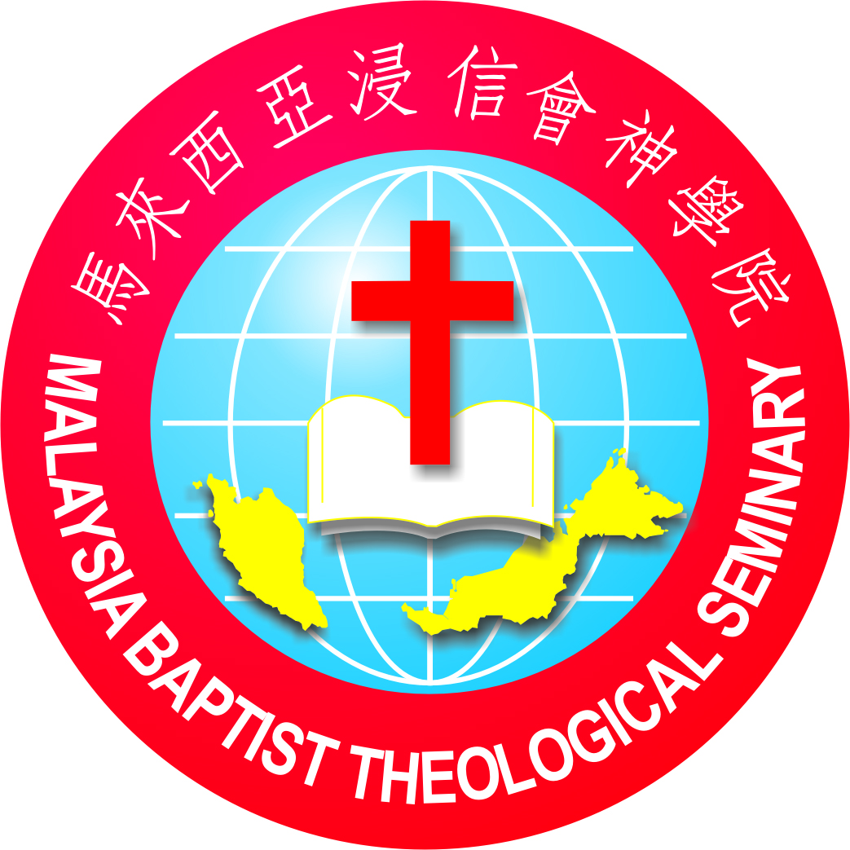
2021 3rd Term English Course Schedule (MBTS Main Campus)

Christian Theology 1 | 2 | Dr. Sunny Tan | Online
Intro to OT 2 | 2 | Dr. Chuah Chia Choon & Eric Pua | Online
Church History 1 | 3 | Chia Wei Wenn | Online
Advanced Preaching | 3 | Dr. Vincent Ooi | Cohort,  continue from 2nd Term
Intro to Sermon Preparation & Delivery | 3 | Dr. Vincent Ooi | For year 2 & 3 students only  (hybrid)
Intro to Conflict Management | 3 | Mrs. Chin Nee Jin | Online
Baptist/Denominational Polity & Study | 3 | Dr. Thomas Chin | Online
The Art of Listening and Responding to God and ourselves | 1 | Dr. Matthew Leong | Online
Theological English | 1 | Mrs. Lauren Kuo | Online

Week 1 – 4 (6 Sept - 1 Oct) ** 16th Sept Malaysia Day
 | Tue | Wed | Thu | Fri
8:00 - 9:45am | Christian Theology 1 (ST) | Intro to OT 2 (JC & EP) | Christian Theology 1 | Intro to OT 2
 | Intro to Sermon Preparation & Delivery (VO)
10:00am | Chapel | Chapel | Graduand Preaching | SF / Mentoring
11:15am – 1:00pm | Church History 1 (WW) | Church History 1 | Church History 1
 | Intro to Conflict Management (NJ) | Intro to Conflict Management | Intro to Conflict Management | Denominational Study
2:00– 5:00pm |  | Denominational Study (TC)
7.00–9.00pm |  | Theological English (LK) | 23/9- 4/11, 8pm-9.30pm  The Art of Listening to Responding (ML)
* Advance Preaching cohort continues from Term 2
** Study Break 2 Oct – 10 Oct
Week 5 – 7 (11 - 29 Oct)
 | Tue | Wed | Thu | Fri
8:00 - 9:45am | Christian Theology 1 (ST) | Intro to OT 2 (JC & EP) | Christian Theology 1 | Intro to OT 2
 | Intro to Sermon Preparation & Delivery (VO)
10:00am | Chapel | Chapel | Graduand Preaching | SF / Mentoring
11:15am – 1:00pm | Church History 1 (WW) | Church History 1 | Church History 1
 | Intro to Conflict Management (NJ) | Intro to Conflict Management | Intro to Conflict Management | Denominational Study
2:00– 5:00pm |  | Denominational Study (TC)
7.00–9.00pm |  | Theological English | 23/9- 4/11, 8pm-9.30pm  The Art of Listening to Responding (ML)

Week 8 (1 – 5 Nov)
 | Tue | Wed | Thu | Fri
8:00 - 9:45am | Christian Theology 1 | Intro to OT 2
10:00am | Chapel | Chapel | Graduand Preaching | SF / Mentoring
11:15am – 1:00pm | Denominational Study | Denominational Study | Denominational Study
7.00–9.00pm | 8pm-9.30pm  The Art of Listening to Responding (ML) | Theological English | 8pm-9.30pm  The Art of Listening to Responding (ML)
* Graduation Service 12th Nov (Fri)

