MALAYSIA BAPTIST THEOLOGICAL SEMINARY
Course Registration Form (English)
2nd Term 2019 (June 3 – Aug 2)

Name : |  | Tel/ H.P: |  |  |  |  |  |  | Student ID:
Email : |  | Status X: |  | Full-time |  | Part-time |  | Modular | Mailbox :

Submit by 4th May 2019 Course Registration Fee RM20 will be waived for those who register before 4th May.
(Cr – Credit ; Aud – Audit)
Cr  X | Aud  X | Code | Course |  |  | Cr |  |  | Date & Time |  | Lecturer
 |  | HCD540 | Family Discipleship |  |  | 3 |  |  | June 3-7  (Mon: 10am-5pm; Tue-Fri:8am-4pm) |  | Pr. Matthew Ling
 |  | TH320 | A History of Christianity in Asia |  |  | 2 |  |  | June 3-7  (Mon: 10am-5pm; Tue-Fri:8am-4pm) |  | Dr. Rosalie Beck
 |  | HCD505 | Theological Foundations for Holistic Child Development |  |  | 2 |  | 3 | June 10-14  (Mon: 10am-5pm; Tue-Fri:8am-4pm) |  | Dr. Sunny Tan &  Dr. Rosalind Lim
 |  | TH321I | Women in Christian History |  |  | 1 |  |  | June 11-14  (Tue-Fri:8am-1pm) |  | Dr. Rosalie Beck
 |  | HCD 542 | Children at Risk and Community Development |  |  | 2 |  | 3 | June 17-21  (Mon: 10am-5pm; Tue-Fri:8am-4pm) |  | Pr. Margaret Loy &  Ms. Lee Soo Choo
 |  | YM101 | Principles of Youth Ministry |  |  | 3 |  |  | June 17-21  (Mon: 10am-5pm; Tue-Fri:8am-4pm) |  | Pr. Steve Kaptain
 |  | ME521 | Missiological Issues for Gen Y/Z in Postmodern Context |  |  | 2 |  |  | June 17-21  (Mon: 10am-5pm; Tue-Fri:8am-4pm) |  | Dr. Emo Yango
 |  | HCD515 | Leadership in Christian NGOs (cancelled) |  |  | 2 |  | 3 | June 24-28  (Mon: 10am-5pm; Tue-Fri:8am-4pm) |  | Elder Toyditz Cosico
 |  | ME101 | Introduction to Christian Mission |  |  | 3 |  |  | June 24-28  (Mon: 10am-5pm; Tue-Fri:8am-4pm) |  | Dr. Paul Hagen
 |  | YM331 | Ministry to Troubled Youth |  |  | 3 |  |  | June 24-28  (Mon: 10am-5pm; Tue-Fri:8am-4pm) |  | Dr. Marv Penner
 |  | BS118M | Tafsiran Alkitab |  |  | 2 |  |  | June 24-28  (Mon: 10am-5pm; Tue-Fri:8am-4pm) |  | Pr. Franklin Karong
 |  | TH110 | Church & End Time  (Christian Theology III) |  |  | 2 |  |  | July 8-12  (Mon: 10am-5pm; Tue-Fri:8am-4pm) |  | Dr. Sunny Tan
 |  | ID346 | Disaster Response |  |  | 2 |  |  | July 15-19  (Mon: 10am-3pm; Tue-Fri:8am-3pm) |  | CREST Team
 |  | NT104 | Gospel of John |  |  | 2 |  |  | July 15-19  (Mon: 10am-5pm; Tue-Fri:8am-4pm) |  | Dr. Lee Chul Woo
 |  | YM347 | Discipleship in Youth Ministry |  |  | 3 |  |  | July 22-26  (Mon: 10am-5pm; Tue-Fri:8am-4pm) |  | Dr. Karen Jones
 |  | ME309 | World Religions in Christian Perspective |  |  | 3 |  |  | July 23-Aug 2  (2 weeks, Tue-Fri: 8am-1pm) |  | Dr. Tan Sooi Ling
 |  | YM403 | Professional Orientation in Youth Ministry  (* for specified group only) |  |  | 3 |  |  | July 29-Aug 2  (Mon: 10am-5pm; Tue-Fri:8am-4pm) |  | Dr. Karen Jones & Ps. Steve Kaptain
 |  | ME501 | Mission Practicum (mission trip only) |  |  | 1 |  |  | 2nd Term 2019
 |  |  | TOTAL Credits: |  |  |  |  |  | Registered Date:
Tue-Fri :  10am Event |  |  |  | Combined Chapel (Preaching) | Combined Chapel  (Vision for the Nations) |  | English Chapel B (Testimony Sharing) |  |  | Formation:  June 7, 21; July 12, 26  Mentoring:  June 14, 28; July 19, Aug 2

2nd Term 2019 (June 3 - Aug 2)

Housing and Meals Reservation

Indicate options by X :

A. Residential & Non-Residential FULL-TIME Students：
X |  |  | Total (Residential) | Total (Non-Residential)
 | 1. | Breakfast (Tue-Fri) | (RM2.00/meal x 32) 64.00 | (RM3.00/meal x 32) 96.00 80.00
 | 2. | Lunch (Mon-Fri) OR | (RM4.00/ meal x 40) 160.00 | (RM7.00/ meal x 40) 280.00
 |  | Lunch (Tue-Fri) | (RM4.00/ meal x 32) 128.00 | (RM7.00/ meal x 32) 224.00
 | 3. | Dinner (Mon-Thu) | (RM4.00/ meal x 32) 128.00 | (RM7.00/ meal x 32) 224.00
 |  | TOTAL RM

* All Residential Students are compulsory to take lunch and dinner
** Meals are not provided during term break (June 29th to July 7th)

B. Part Time/ Modular Student:
Course Fee: |  | Master RM120/ credit |  |  | Bachelor RM80/ credit |  | TOTAL Course Fee:
1. | Campus Accommodation [Indicate Date, Time and Type of housing] : |  |  |  |  |  | * Rate per week: Single RM200 / Sharing RM150 / Dormitory RM110  ( Type of housing is subjected to availability) Indicate options by X
 | Check In Date: |  |  |  |  | Check In Time: |  |  | Single |  |  | Sharing |  | Dorm
 | Check Out Date: |  |  |  |  | Check Out Time: |  |  | Gender |  |  | Male |  | Female
2. | Meals [Indicate Dates]
 | Breakfast (RM3/ meal) Dates: |  |  |  |  |  |  | Total B/F |  |  |  | X RM3
 | Lunch (RM7/ meal) Dates: |  |  |  |  |  |  | Total Lunch |  |  |  | X RM7
 | Dinner (RM7/ meal) Dates: |  |  |  |  |  |  | Total Dinner |  |  |  | X RM7
 |  |  |  |  |  |  |  | Total Cost of housing and meals

REMARKS:
- Keys @ MultiPlex : acquire at Postbox (code: 240)
Prefered check in time:
Sunday 5pm-10pm, or Monday 2pm-10pm

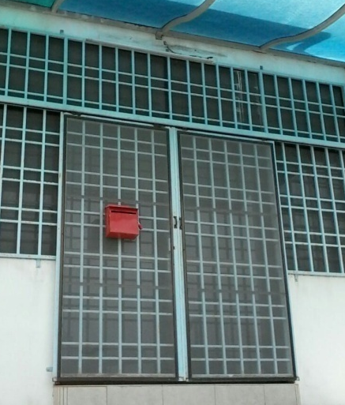
- Keep your room tidy and foodstuffs stored securely [prevent ants & rats...].
- On departure, please:
i. Clear rubbish in a plastic bag and dispose it at rubbish cage (main entrance).
ii. Place bed linen into the pillow case and leave on the bed.
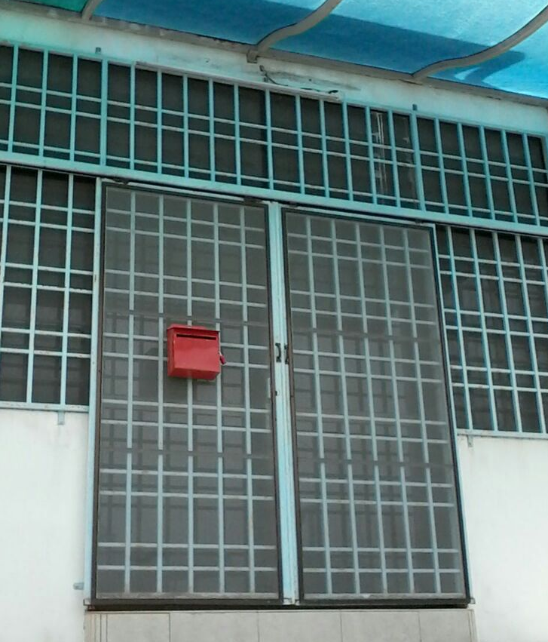
iii. Return keys to the key box.

Thank you for your co-operation and understanding.

School of Trans-Cultural Mission (STCM) 2nd Term 2019 updated: 21 March

** All Monday Classes start @ 10am

Jun 3-7 (1st week)
 | Mon (3/6) | Tue (4/6) | Wed (5/6) | Thu (6/6) | Fri (7/6) | Sat
7.00 - 7.30 |  | Morning Prayer |  |  |  | Outreach Activities/Ministry in local church
7.30 - 8.00 | Breakfast
8.00 - 9.45 | Mon starts@10am | Family Discipleship  Room: C8
 |  | A History of Christianity in Asia Room: C7
10.00 - 11.00 |  | Chapel (Combined) | Vision for nation | Testimony Sharing | Spiritual Formation
11.15 - 13.00 | Family Discipleship
 |  | A History of Christianity in Asia
13.00 - 14.00 | Lunch
14.00 - 16.00 | Mon ends @5pm | Family Discipleship
 |  | A History of Christianity in Asia
18.00 - 19.00 | Dinner

Jun 10-14 (2nd week)
 | Mon (10/6) |  | Tue (11/6) | Wed (12/6) | Thu (13/6) | Fri (14/6) | Sat
7.00 - 7.30 |  |  | Morning Prayer |  |  |  | Outreach Activities/Ministry in local church
7.30 - 8.00 | Breakfast
8.00 - 9.45 | Mon starts@10am |  | Theological Foundations for Holistic Child Development Room: C8
 |  |  | Women in Christian History Room: C7
10.00 - 11.00 |  |  | Chapel (Combined) | Vision for nation | Testimony Sharing | Small Group
11.15 - 13.00 | Theological Foundations for Holistic Child Development
 |  | Women in Christian History
13.00 - 14.00 | Lunch
14.00 - 16.00 | Mon ends @5pm |  | Theological Foundations for Holistic Child Development
18.00 - 19.00 | Dinner

Jun 17-21 (3rd week)
 | Mon (17/6) | Tue (18/6) | Wed (19/6) | Thu (20/6) | Fri (21/6) | Sat
7.00 - 7.30 |  | Morning Prayer |  |  |  | Outreach Activities/Ministry in local church
7.30 - 8.00 | Breakfast
8.00 - 9.45 | Mon starts@10am | Children at Risk and Community Development Room: C8  Implications for Pastoral Care
 |  | Principles of Youth Ministry
 |  | Missiological Issues for Gen Y/Z in Postmodern Context
10.00 - 11.00 |  | Chapel (Combined) | Vision for nation | Testimony Sharing | Spiritual Formation
11.15 - 13.00 | Children at Risk and Community Development  Implications for Pastoral Care
 | Principles of Youth Ministry
 | Missiological Issues for Gen Y/Z in Postmodern Context
13.00 - 14.00 | Lunch
14.00 - 16.00 | Mon ends @5pm | Children at Risk and Community Development
 |  | Principles of Youth Ministry
 |  | Missiological Issues for Gen Y/Z in Postmodern Context
18.00 - 19.00 | Dinner

Jun 24-28 (4th week)
 | Mon (24/6) | Tue (25/6) | Wed (26/6) | Thu (27/6) | Fri (28/6) | Sat
7.00 - 7.30 |  | Morning Prayer
7.30 - 8.00 | Breakfast
8.00 - 9.45 | Mon starts@10am | Leadership in Christian NGOs
 |  | Introduction to Christian Mission
 |  | Ministry to Troubled Youth
 |  | Tafsiran Alkitab
10.00 - 11.00 |  | Chapel (Combined) | Vision for nation | Testimony Sharing | Small Group
11.15 - 13.00 | Leadership in Christian NGOs
 | Introduction to Christian Mission
 | Ministry to Troubled Youth
 | Tafsiran Alkitab
13.00 - 14.00 | Lunch
14.00 - 16.00 | Mon ends @5pm | Leadership in Christian NGOs
 |  | Introduction to Christian Mission
 |  | Ministry to Troubled Youth
 |  | Tafsiran Alkitab
18.00 - 19.00 | Dinner

School of Trans-Cultural Mission (STCM) 2nd Term 2019
June 29 - July 7 Study Break

July 8-12 (5th week)
 | Mon (8/7) | Tue (9/7) | Wed (10/7) | Thu (11/7) | Fri (12/7) | Sat
7.00 - 7.30 |  | Morning Prayer |  |  |  | Outreach Activities/Ministry in  local church
7.30 - 8.00 | Breakfast
8.00 - 9.45 | Mon starts@10am Revelation | Church & End Time (Christian Theology III) Room:
10.00 - 11.00 |  | Chapel (Combined) | Vision for nation | Testimony Sharing | Spiritual Formation
11.15 - 13.00 | Church & End Time (Christian Theology III)
13.00 - 14.00 | Lunch
14.00 - 16.00 | Mon ends @5pm | Church & End Time (Christian Theology III)
18.00 - 19.00 | Dinner

July 15-19 (6th week)
 | Mon (15/7) |  | Tue (16/7) |  | Wed (17/7) | Thu (18/7) | Fri (19/7) | Sat
7.00 - 7.30 |  |  | Morning Prayer |  |  |  |  | Outreach Activities/Ministry in local church
7.30 - 8.00 | Breakfast
8.00 - 9.45 | Mon starts@10am | Disaster Response Room:
 |  | Gospel of John Room:
10.00 - 11.00 |  | Chapel (Combined) |  |  | Vision for nation | Testimony Sharing | Small Group
11.15 - 13.00 |  | Disaster Response
 |  | Gospel of John
13.00 - 14.00 | Lunch
14.00 - 16.00 | Everyday ends @ 3pm |  |  | Disaster Response
 | Mon ends @5pm |  | Gospel of John
18.00 - 19.00 | Dinner

July 22-26 (7th week)
 | Mon (22/7) | Tue (23/7) |  | Wed (24/7) | Thu (25/7) | Fri (26/7) | Sat
7.00 - 7.30 |  | Morning Prayer |  |  |  |  | Outreach Activities/Ministry in local church
7.30 - 8.00 | Breakfast
8.00 - 9.45 | Mon starts@10am | Discipleship in Youth Ministry Room:
 |  | World Religions in Christian Perspective Room:
10.00 - 11.00 |  | Chapel (Combined) |  | Vision for nation | Testimony Sharing | Spiritual Formation
14.00 - 16.00 |  | Discipleship in Youth Ministry
 |  | World Religions in Christian Perspective
13.00 - 14.00 | Lunch
14.00 - 16.00 | Mon ends @5pm | Discipleship in Youth Ministry
18.00 - 19.00 | Dinner
19.00 - 20.30 |  | STCM Celebration

July 29-Aug 3 (8th week)
 | Mon (29/7) | Tue (30/7) | Wed (31/7) | Thu (1/8) | Fri (2/8) | Sat
7.00 - 7.30 |  | Morning Prayer
7.30 - 8.00 | Breakfast
8.00 - 9.45 |  | World Religions in Christian Perspective
 | Mon starts@10am | Professional Orientation in Youth Ministry
10.00 - 11.00 |  | Chapel (Combined) | Vision for nation | Testimony Sharing | Small Group
11.15 - 13.00 |  | World Religions in Christian Perspective
 |  | Professional Orientation in Youth Ministry
13.00 - 14.00 | Lunch
13.00 - 16.00 | Mon ends @5pm | Professional Orientation in Youth Ministry
18.00 - 19.00 | Dinner

STCM Youth Ministry Classes 2019

YM 101 Principles of Youth Ministry June 17-21
Ps. Steve Kaptain
A brief history of the growth of student ministries, orientation to various student ministry positions, principles necessary for successful student programming, and a survey of methodology involved will be studied. Special attention will be given to developing a strategy for making disciples of the next generation.

YM 331 Ministry to Troubled Youth June 24-28
Dr. Marv Penner
Effective youth workers can build relationships with young peoplethat provide the opportunity to minister and provide care before personal problems reach a critical level. This class will examine typical conflicts that the contemporary student confronts in real life. Special attention will be given to conflict resolution in relationships and spiritual giftedness, temperament, and group process.

YM 347 Discipleship in Youth Ministry July 22-25
Dr. Karen Jones
How does the youth worker create an environment in the local church youth group that will maximize spiritual growth for young people? Principles and methods of spiritual maturing in the context of the social, physical, and cultural youth development will be explored to answer this question.

Professional Orientation in Youth Ministry July 29-August 2
Dr. Karen Jones and Ps. Steve Kaptain
Students will focus on their call to ministry examining personal growth and commitment. Special attention will be given to how to train other youth workers in both informal and formal academic settings. Consideration will be given to contextualizing training with the Asian youth worker in mind. This course will be limited to students who have completed all ten youth ministry training modules, youth ministry alumni, and/or those who are interested in training others for ministry to the next generation.

Ps. Steve Kaptain
Steve Kaptain is the Asia Area Director for Youth Ministry International (YMI), a ministry that multiplies youth ministry trainers across the globe. He joined YMI after serving in Nepal for fourteen years, and serving as a local church youth pastor in the United States for several years before that. Through his current ministry he has helped develop and start new youth ministry training programs in China, Indonesia, Myanmar, Nepal, and Malaysia. He is currently a candidate for the doctorate of missiology program at Malaysia Baptist Theological Seminary (MBTS) where he also serves as the director of the Center for Youth Ministry (CYM). He spends his free time, what little he has, working out or enjoying time with his wife Anju and their three children.

Dr. Karen Jones
Currently teaches youth ministry at Huntington University in Indiana. She has over 15 years of experience working with youth in the local church, and continues to minister with them by giving leadership to student mission projects each year, both in the United States and internationally. Jones has served on the boards of the North American Professors of Christian Education and on the executive leadership team for the International Association for the Study of Youth Ministry. She is currently on the executive board of the Association of Youth Ministry Educators.

Dr. Marv Penner
Is an Associate Staff member of The Center for Parent/Youth Understanding. He is an internationally-known author, professor, motivational speaker, and youth ministry expert. He is currently the executive director of All About Youth and Youth Specialties Canada.
Marv is a frequent speaker at the National Youth Workers Convention. He has authored youth curriculum for Gospel Light Publications and Cook Communications and is the author of such youth ministry books as The Youth Worker’s Guide to Parent Ministry, published by Youth Specialties/Zondervan and Hope and Healing For Kids Who Cut, also published by Youth Specialties/Zondervan.
In addition to his teaching, speaking and writing, Marv is a licensed marriage and family counselor specializing in parent/adolescent conflict resolution, sexual abuse recovery, eating disorders and marriage and family issues. He received his MA degree from Grace Seminary in 1985, and his D.Phil degree from Oxford Graduate School in 1993.
Marv and his wife, Lois, live in British Columbia, Canada, and have three married children.

